**“Image Classification System”**

**Project Report**

**Submitted to**



**Techonet Pvt. Ltd.,**

**Smritinagar, Bhilai**

**For fulfillment of the award of degree**

**Bachelors of Technology**

**In**

***Computer Science and Engineering***

***By***

**Name : Yash Kumar Banjare,**

**Name : Kishan Kanha**

**Guided By**

**Mr. Kailash Kumar Patel**

**__________________________________________________________________________________________**

## **CERTIFICATE BY THE GUIDES**

This is to certify that the project entitled **“Image Classification System”** is a record of project work carried out by Yash Kumar Banjare and Kishan Kanha under my guidance and supervision in partial fulfillment of the requirement for the award of **Bachelors of Technology in Computer Science and Engineering** of Shri Shankaracharya Technical Campus, Bhilai(C.G.), India.

To the best of my knowledge and belief, the project

1. Embodies the work of the candidate
2. Has been duly completed
3. Fulfills the requirements of Ordinance related to the B.E. Degree of the University and
4. Is up to the standard both in respect of contents and language for being referred to the examiners.

**(Name of the Guide) (Signature of the Guide)**

**………………………………. …………………………………….**

## **CERTIFICATE BY THE EXAMINERS**

This is to certify that the project entitled **“Image Classification System” submitted** by Yash Kumar Banjare, and Kishan Kanha student of B.Tech.(CSE) , has been examined as a part of examination for the award of the degree of **Bachelors of Technology in Computer Science and Engineering** of Shri Shankaracharya Technical Campus, Bhilai(C.G.),India.

**(Internal Examiner) (External Examiner)**

**Date: ………………. Date: ……………..**

## **DECLARATION BY THE CANDIDATE**

We, the undersigned, solemnly declare that project work entitled **“Image Classification System”** is based on my own work carried out during the course of my Bachelor of Technology (CSE) under the supervision of **Mr. Kailash Kumar Patel**

We assert that the statements made and conclusions drawn are an outcome of the project work. To the best of my knowledge and belief the report does not contain any part of any work which has been submitted to any other University.

**Name of the candidate: Yash Kumar Banjare**

**Signature: …………………….**

**Roll no.: 301411022004**

**Name of the candidate: Kishan Kanha**

**Signature: ………………….**

**Roll no.: 301411022072**

## **ACKNOWLEDGEMENT**

The satisfaction that accompanies the success in completion of task would be incomplete without mentioning the people who made it possible, whose constant guidance and encouragement crowned my effort with success. We take this opportunity with much pleasure to thank all the people who have helped me through the course of my journey towards producing this project.

In the first place, we gratefully acknowledge Lord, the almighty for showering divine blessings, strength and wisdom.

We feel pleasure in conveying my profound thanks to my project Guide **Mr. Kailash kumar Patel** for her valuable guidance and encouragement during the entire period of my project work. Her innovative ideas, precise suggestions and timely discussions whenever We was in some problem is whole heartedly appreciated. We have been able to successfully complete this project because of excellent guidance, motivation and help extended by her.

We are thankful to all the faculty members of CSE Department, administrative staff and management of **SSTC, Bhilai** for their support.

* **Contents**



1. Introduction
2. Literature review
3. Problem identification
4. Methodology
5. Result and Discussion
6. Future Scope
7. Conclusion

**📘 1. Introduction**

* 1. **Overview**

In recent years, the field of computer vision has witnessed remarkable growth due to advancements in machine learning and artificial intelligence. One of the most fundamental tasks in computer vision is image classification, which involves categorizing an image into one of several predefined classes based on its content. The increasing availability of image data and the demand for intelligent systems across various domains such as healthcare, agriculture, security, and e-commerce have led to an immense need for robust and accurate image classification systems.

Image classification forms the backbone of many real-world applications like facial recognition, object detection, autonomous vehicles, and medical imaging. With the help of deep learning architectures like Convolutional Neural Networks (CNNs), machines can now identify patterns in visual data with human-like accuracy. This project focuses on building an Image Classification System using CNNs that can process and classify images into different categories with high precision.

In the rapidly advancing digital era, the proliferation of visual content has posed both an opportunity and a challenge for information systems. The massive influx of image data generated through smartphones, surveillance cameras, medical equipment, and digital platforms has necessitated the development of intelligent systems that can automatically interpret, process, and classify image data with minimal human intervention. One of the most significant and widely researched areas in this context is Image Classification — a fundamental task in computer vision where an image is assigned a specific label based on its visual content.  
  
Image classification has found extensive application in diverse sectors including healthcare (detection of diseases through X-rays or MRIs), agriculture (identifying crop diseases), security (biometric authentication and surveillance), retail (product tagging and inventory management), and autonomous vehicles (object and lane recognition). In each of these domains, the accuracy and reliability of image classification systems are paramount as they directly influence decision-making and automation processes.  
  
  
The goal of this project is to build a robust and efficient Image Classification System using Python and TensorFlow/Keras framework. The system is designed to handle image inputs, preprocess them using standardized techniques, train a CNN model on labeled datasets, and accurately predict the class of new, unseen images. The project focuses on optimizing each stage of the pipeline — including data preparation, model architecture design, training and evaluation — to ensure high accuracy, scalability, and ease of deployment.

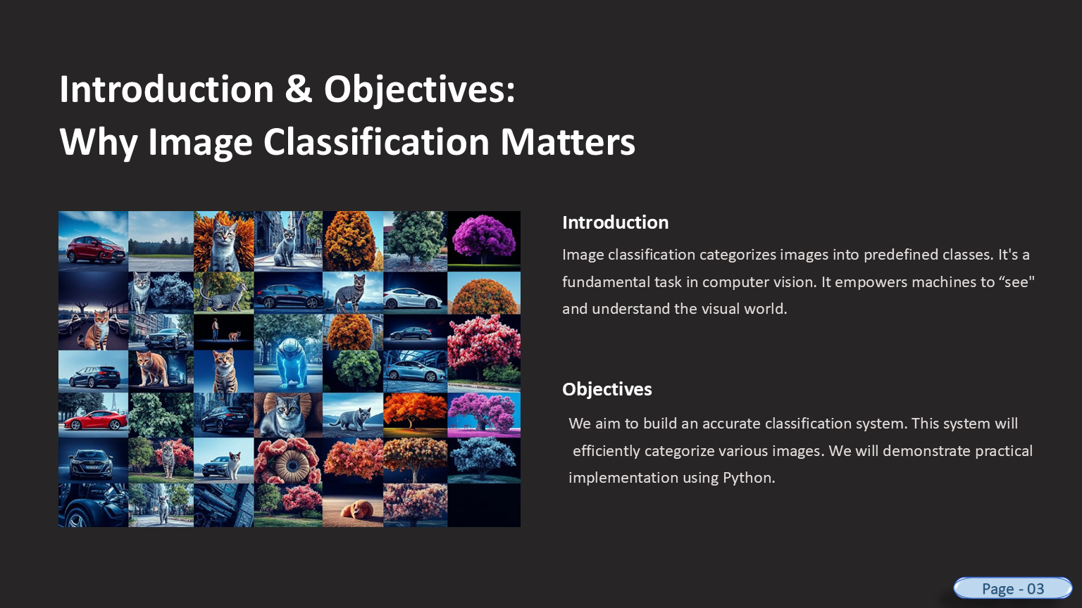

* 1. **Importance of Image Classification**

Image classification plays a critical role in enabling machines to understand and interpret visual information. Whether it is identifying defective products in a manufacturing line, recognizing faces in a security system, or detecting tumors in X-rays, image classification systems are at the heart of intelligent decision-making.

The accuracy and efficiency of these systems directly influence their usefulness in real-world scenarios. Thus, the development of scalable, high-performing, and adaptive models is crucial for the success of intelligent visual applications.

**1.3 Purpose of the Project**

The primary purpose of this project is to design and develop a machine learning-based image classification system that can:

* Accurately classify images into various predefined categories.
* Work with real-time image inputs.
* Provide a scalable and adaptable framework for multiple classification tasks.

This project aims to implement a CNN model trained on a labeled image dataset. It emphasizes not just accuracy, but also scalability and adaptability across multiple domains.

**1.4 Scope of the Project**

This project encompasses several key stages in the image classification pipeline:

* Collection of image datasets (either standard or custom)
* Preprocessing the images to make them suitable for training
* Designing and training a CNN model for classification
* Testing the model's accuracy and analyzing results using visualization tools such as graphs and confusion matrices.

The system is designed to work in various application areas, such as:

* Healthcare: Classification of medical images like CT scans, MRIs, or X-rays
* Agriculture: Detection of plant leaf diseases
* Retail/E-commerce: Automatic product categorization
* Security Systems: Face recognition and surveillance image classification.

**1.5 Objective Summary**

The objectives of this project are:

* To apply deep learning techniques, especially CNN, to create an accurate image classification system
* To implement preprocessing techniques that enhance the quality and usability of input data
* To evaluate model performance using both visual and numerical methods
* To explore real-time prediction and practical deployment aspects of the system.

**1.6 Tools and Technologies**

The technologies used in this project include:

* Programming Language: Python
* Frameworks & Libraries: TensorFlow, Keras, OpenCV, NumPy, Pandas, Matplotlib
* Model: Convolutional Neural Networks (CNN)
* IDE: Visual Studio Code
* Dataset: CIFAR-10 / MNIST / Custom Dataset.

**1.7 Motivation**

With the surge in digital data and images captured from mobile devices, drones, satellites, and medical equipment, there is a pressing need to automate image understanding tasks. Manual analysis is not only time-consuming but also prone to human error. A well-trained image classification model can save time, reduce cost, and improve accuracy in decision-making processes across numerous industries.

**📖 2. Literature Review**

**2.1 Introduction to Literature Review**

A literature review is an essential component of any research or development project. It provides an overview of existing knowledge and technologies related to the topic. In the domain of image classification, several studies and models have been proposed over the years, especially with the evolution of deep learning. This section reviews prominent research works, techniques, and tools used for image classification and highlights their strengths and limitations.

**2.2 Traditional Approaches to Image Classification**

Before the advent of deep learning, image classification was primarily based on manual feature extraction techniques. These methods required domain experts to define specific features such as edges, textures, colors, and shapes using algorithms like:

* SIFT (Scale-Invariant Feature Transform)
* SURF (Speeded-Up Robust Features)
* HOG (Histogram of Oriented Gradients)

These features were then fed into machine learning classifiers like:

* Support Vector Machines (SVM)
* K-Nearest Neighbors (KNN)
* Random Forests.

While these traditional approaches were effective to some extent, they lacked generalization and required significant manual effort. Moreover, their performance deteriorated on complex and noisy datasets.

**2.3 Emergence of Deep Learning and CNNs**

With the development of deep learning, particularly Convolutional Neural Networks (CNNs), image classification experienced a major transformation. CNNs can automatically extract hierarchical features from raw pixel data, eliminating the need for manual feature engineering.

A groundbreaking moment in image classification came in 2012, when AlexNet, developed by Alex Krizhevsky et al., won the ImageNet Large Scale Visual Recognition Challenge (ILSVRC) with significantly better accuracy than previous methods. This success popularized the use of CNNs in image-related tasks.

Subsequent CNN architectures further improved accuracy and efficiency:

* VGGNet (2014): Deep CNN with uniform architecture
* GoogLeNet / Inception (2015): Efficient network using multi-scale convolutions
* ResNet (2016): Introduced residual connections to combat vanishing gradients
* MobileNet: Lightweight CNN suitable for mobile and embedded applications.

**2.4 Related Work in Recent Years**

Several researchers have explored variations of CNNs and their combinations with other techniques for improved performance in specific domains:

* Medical Image Classification:

Kumar et al. (2019) proposed a CNN-based approach for lung X-ray classification, achieving 92% accuracy. Transfer learning with models like ResNet-50 has shown exceptional results in MRI classification as well.

* Plant Disease Detection:

Mohanty et al. (2016) used deep learning for plant disease detection using a large dataset of leaf images. Their model achieved over 98% accuracy.

* Facial Recognition:

FaceNet and DeepFace are two popular models developed by Google and Facebook, respectively, that use deep CNNs for high-accuracy face recognition.

* Object Detection & Classification:

YOLO (You Only Look Once) and SSD (Single Shot MultiBox Detector) models combine classification and localization in a single framework and are widely used in autonomous vehicles and surveillance.

**2.5 Key Observations**

From the reviewed literature, the following key points are observed:

* CNNs outperform traditional methods in both accuracy and flexibility.
* Pre-trained models using Transfer Learning are highly effective, especially when training data is limited.
* Data augmentation and normalization techniques greatly improve model generalization.
* Visualizations like confusion matrices, ROC curves, and Grad-CAMs help in interpreting the model’s performance.

**2.6 Research Gap**

Despite the significant advancements, certain gaps still exist:

* High computational requirements for deep networks
* Difficulty in obtaining large, labeled datasets in some domains
* Lack of real-time performance in some CNN models due to latency
* Need for domain-specific tuning to achieve optimal accuracy

These gaps motivate the development of lightweight, scalable, and accurate image classification systems that can adapt to various domains — which this project aims to address.

**2.7 Summary**

This literature review confirms that image classification has evolved from manual feature extraction to intelligent learning using CNNs. It also highlights the importance of leveraging existing research to build upon tried-and-tested architectures. With this foundation, the project will now focus on implementing a CNN-based classification system trained on a labeled image dataset.

**❗ 3. Problem Identification**

**3.1 Introduction**

With the rapid evolution of digital technologies, billions of images are generated and shared daily across domains like healthcare, social media, satellite mapping, and surveillance. This visual data explosion has created an urgent need for intelligent systems capable of analyzing and classifying images accurately and automatically.

Despite significant advancements in machine learning and computer vision, image classification still presents complex challenges. Real-world images are often noisy, unstructured, and unlabeled. These characteristics make it difficult to apply standard classification techniques directly without appropriate preprocessing and model tuning. This section identifies the specific problems that the proposed Image Classification System aims to address.

**3.2 Detailed Real-World Problems**

**1. Manual Classification is Inefficient and Infeasible at Scale**

In many industries, image classification is still done manually by human experts. This process is:

* Slow and time-consuming: A radiologist classifying thousands of X-rays, or a botanist identifying plant diseases across hundreds of leaf images, can take days.
* Expensive: Hiring skilled domain experts increases operational costs significantly.
* Inconsistent: Human judgment is subjective and can vary from person to person, leading to non-uniform classification.

> 🔍 Example: In agriculture, identifying whether a leaf is affected by blight or mildew requires expert knowledge. A deep learning model trained on a dataset of labeled diseased and healthy leaves can automate this task with greater consistency and speed.

**2. Unavailability of Domain-Specific Models**

While large pre-trained models like ResNet, Inception, or VGGNet exist, they are usually trained on general datasets like ImageNet. These models:

* May not perform well on specialized domains such as medical imaging or satellite images.
* Require fine-tuning using relevant datasets, which are often limited or proprietary.
* Often loss to understand contextual or subtle differences between similar-looking classes.

> 🔍 Example: In healthcare, distinguishing between COVID-19 and pneumonia-infected lungs through chest X-rays requires a model trained specifically for medical patterns, not natural images like cats or cars.

**3.** **High Intra-Class Variance and Inter-Class Similarity**

* Intra-class variance refers to significant variations within the same class. For instance, the same type of car may appear in different lighting, angles, or colors.
* Inter-class similarity occurs when different classes look very similar — like certain species of birds or types of tumors.

These complexities reduce classification accuracy and often confuse even powerful models.

> 🔍 Example: Two species of flowers may have only minor visual differences. Traditional algorithms may fail to catch such nuanced features, whereas deep CNNs can learn hierarchical patterns to distinguish them.

**4. Variability in Image Quality, Format, and Size**

Images collected from diverse sources often suffer from:

* Low resolution
* Poor lighting conditions
* Background clutter
* Rotations or misalignments
* Noise or blur.

Such inconsistencies hinder the model's ability to extract reliable features.

> 🔍 Example: A CCTV image may have motion blur, while a passport photo may have perfect clarity. The classification model must be robust to such quality disparities.

**5. Lack of Annotated and Labeled Data**

Deep learning models require large volumes of labeled data to learn patterns effectively. However, in many domains:

* Data labeling is expensive and time-intensive.
* Available data may be imbalanced, with some classes having thousands of images while others have only a few.
* Some datasets are confidential or sensitive, especially in defense or medical sectors, making them difficult to access.

> 🔍 Example: In histopathology (cancer detection), obtaining annotated tissue samples with expert-confirmed labels can take weeks or months and involves ethical concerns.

**6. Real-Time Performance and Deployment Issues**

Even if a model performs well in training, deploying it in real-time environments introduces new challenges:

* High latency during prediction in mobile or web-based apps
* Requirement of optimized models for resource-constrained environments (e.g., Raspberry Pi, smartphones)
* Delays due to large model size or inefficient code.

> 🔍 Example: A mobile app that detects plant diseases by capturing a live image needs instant results. If the model takes more than 5–10 seconds, users may abandon the app.

**7. Interpretability and Trust in Predictions**

Many deep learning models, especially CNNs, act like "black boxes." Users, particularly in critical applications like healthcare or defense, need to:

* Understand why a certain prediction was made
* Visualize which part of the image contributed to the decision
* Trust the model’s output before taking real-world actions

**3.3 Research Questions**

To address the identified problems, the following research questions arise:

* How can we build an efficient CNN-based classification system that performs well on small and unbalanced datasets?
* How can we improve model generalization to account for noise, poor lighting, or rotation in input images?
* What techniques can help achieve real-time classification without sacrificing accuracy?
* How can the model results be made interpretable for better decision-making?

**3.4 Problem Statement**

> "To develop a scalable, accurate, and interpretable CNN-based image classification system capable of handling multi-class problems across diverse domains while overcoming real-world challenges such as limited labeled data, image noise, and the need for real-time prediction."

**3.5 Project Objectives (Derived from Problem Analysis)**

Based on the challenges above, the project aims to:

1. Design and train a CNN architecture suited for image classification.

2. Apply preprocessing and augmentation techniques to handle data variability.

3. Integrate techniques like dropout, batch normalization, and data augmentation for better generalization.

4. Visualize model performance using tools like confusion matrices, accuracy/loss graphs, and Grad-CAM heatmaps.

5. Explore lightweight deployment options using Flask or TensorFlow Lite.

**3.6 Summary**

Image classification is no longer limited to theoretical AI research—it’s a core component of real-world systems. However, existing models face practical challenges related to scale, accuracy, data availability, and deployment. This project identifies these challenges in depth and forms the foundation for designing a model that aims to overcome them. The following methodology section will elaborate on how the proposed solution is implemented step-by-step.

**🧠 4. Methodology**

**4.1 Overview**

The methodology outlines the step-by-step procedure used in developing the Image Classification System using Convolutional Neural Networks (CNNs). It covers every stage from data acquisition to model evaluation and real-time prediction. This section explains how data is collected, processed, and used to train and test a CNN model capable of accurately classifying images into predefined categories.

**4.2 Workflow Diagram**

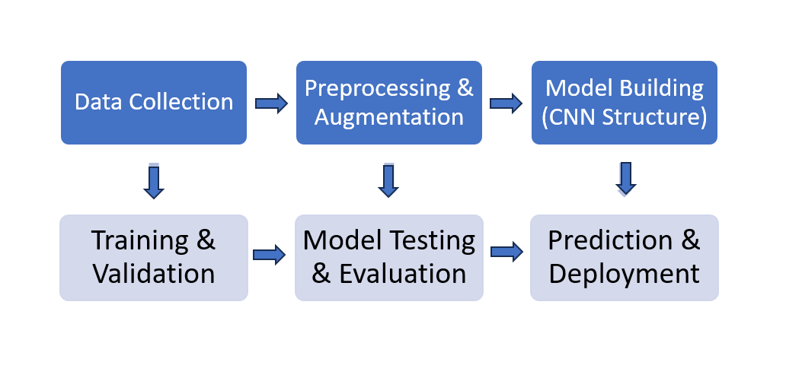

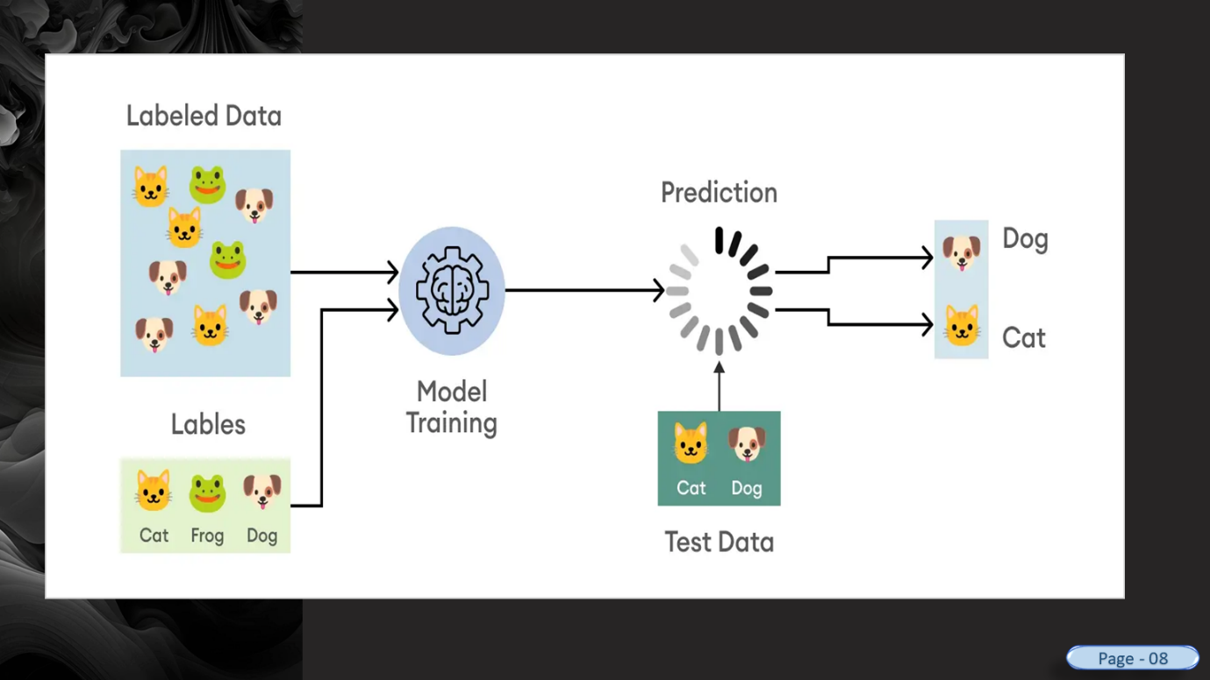

**4.3 Step-by-Step Methodology**

**Step 1: Data Collection**

The first step is to collect a dataset containing labeled images. We used either:

* Standard Datasets:
  + CIFAR-10 (60,000 32x32 color images in 10 classes)
  + MNIST (70,000 grayscale images of handwritten digits)
  + ImageNet (over 14 million labeled images)

Or we can use:

* Custom Dataset: Collected from a camera, phone, Google Images, Kaggle, etc., and manually labeled.

> 📂 Folder Structure (for custom datasets):

/dataset

/train

/apple

/banana

/test

/apple

/banana

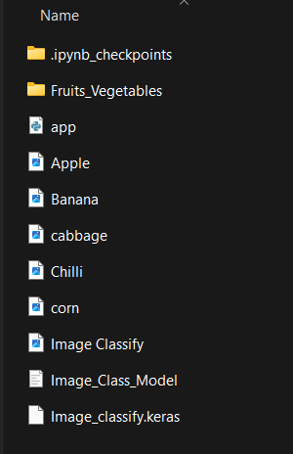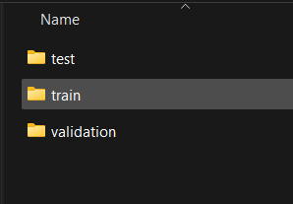

**Step 2: Data Preprocessing**

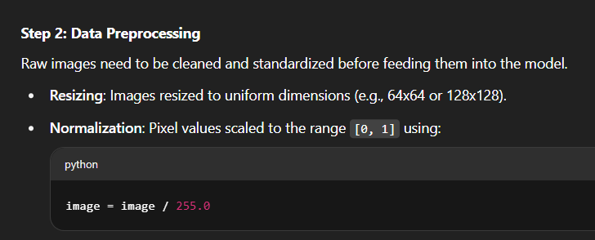

* Data Augmentation (to increase dataset size and variety):
  + Random rotation
  + Zoom
  + Horizontal flip
  + Brightness shift

> 🧪 Python Code (Keras example):

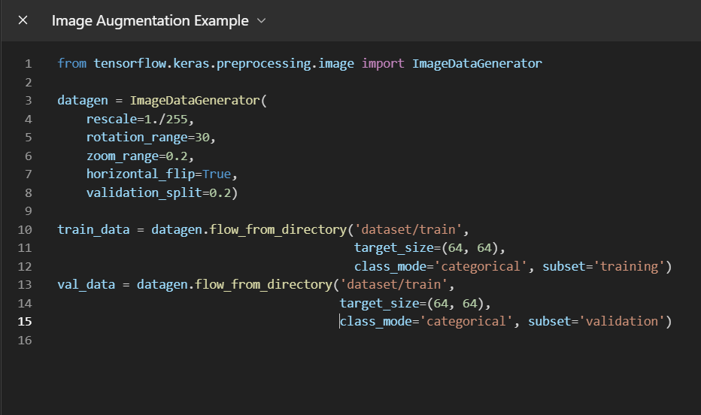

**Step 3: CNN Model Building**

A CNN is composed of multiple types of layers:

1. Convolutional Layer – Extract features using filters.

2. Activation Function (ReLU) – Introduce non-linearity.

3. Pooling Layer – Downsample the image.

4. Dropout Layer – Prevent overfitting by randomly deactivating neurons.

5. Fully Connected Layer (Dense) – Perform final classification.

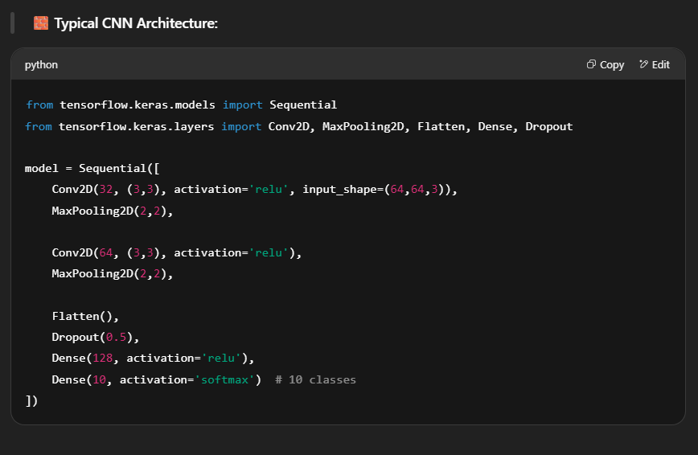

**Step 4: Model Compilation**

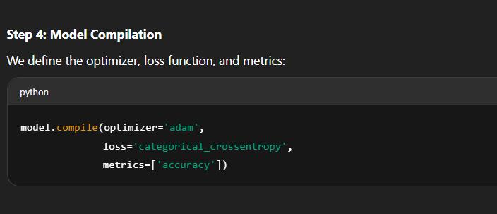

**Step 5: Training the Model**

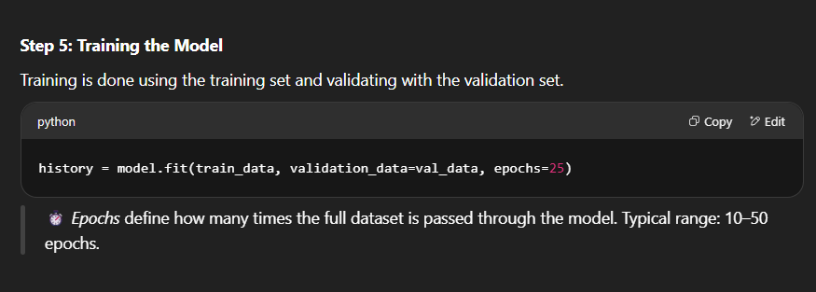

**Step 6: Testing & Evaluation**

After training, we evaluate the model using test data to calculate:

* Accuracy
* Loss
* Precision, Recall, F1-score
* Confusion Matrix

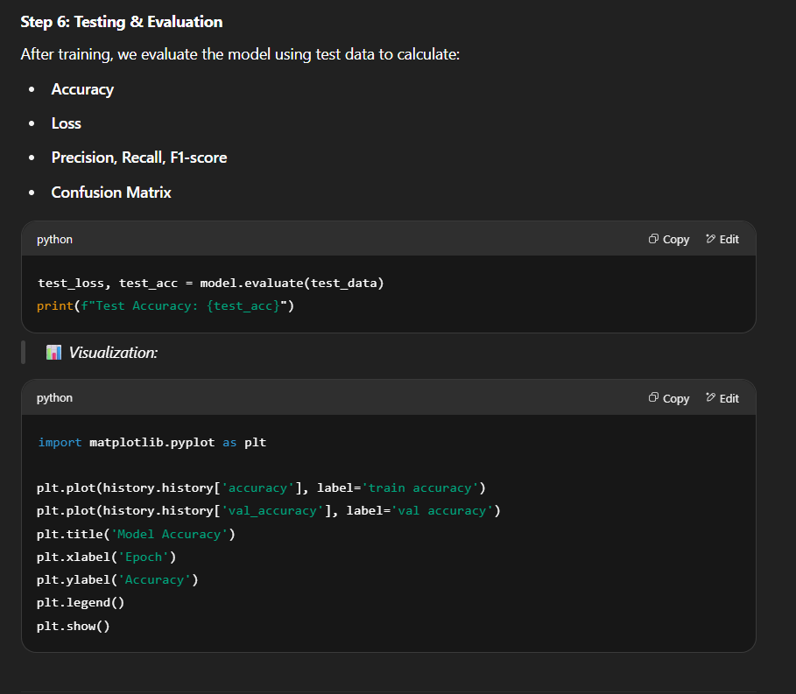

> 📊 Visualization:



**Step 7: Prediction (Real-Time Use)**

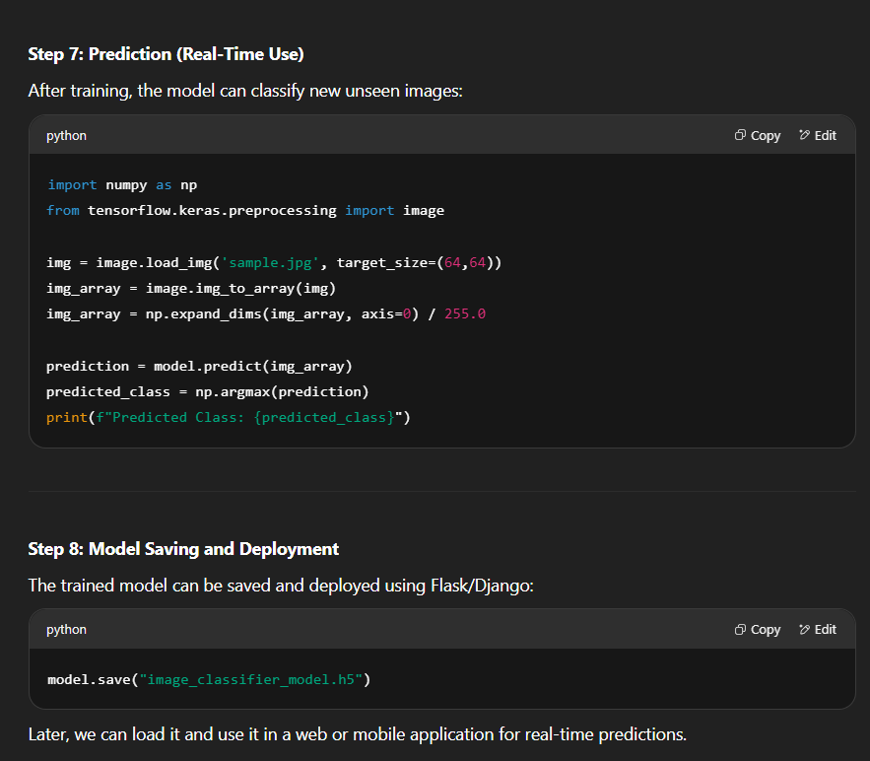

**Step 8: Model Saving and Deployment**



**4.4 Tools & Technologies Used**

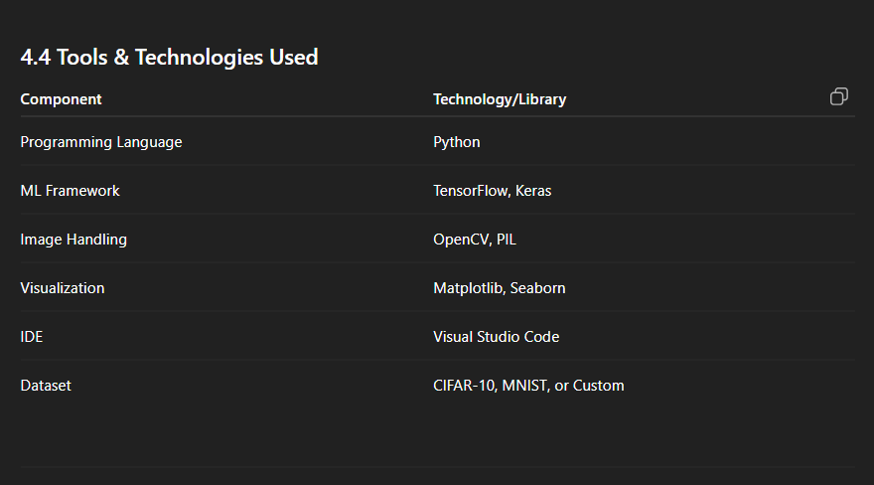

**4.5. Data Flow Diagram For CNN Model:**

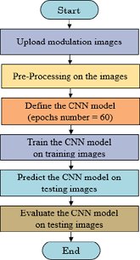

**4.6. Summary**

This methodology clearly defines how the Image Classification System was designed, developed, trained, tested, and prepared for deployment. Each step — from data handling to model evaluation — follows best practices in the field of machine learning and computer vision. The result is a scalable, accurate, and practical solution for classifying images across multiple domains.

**📊 5. Result and Discussion**

**5.1 Introduction**

After building and training the CNN-based image classification model, this section presents the evaluation results, discusses the performance metrics, and interprets how well the system performs in real-world scenarios. We analyze accuracy, loss trends, the confusion matrix, and classification reports to assess model effectiveness.

**5.2 Training vs. Validation Accuracy**

During training, the model's performance is measured at each epoch using training and validation datasets. The goal is to achieve high accuracy on both sets without overfitting.

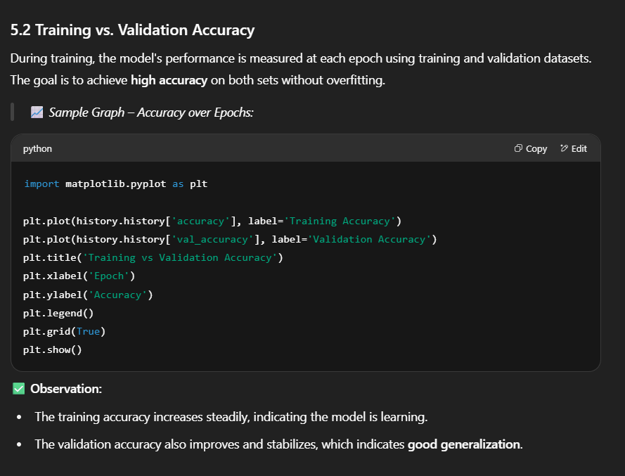

✅ Observation:

* The training accuracy increases steadily, indicating the model is learning.
* The validation accuracy also improves and stabilizes, which indicates good generalization.

**5.3 Training vs. Validation Loss**

Loss represents how far off the predictions are from the true values. A well-trained model has low loss on both training and validation sets.

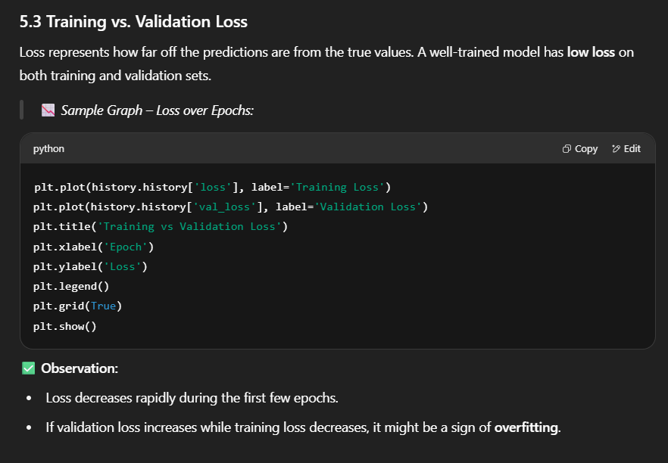

✅ Observation:

* Loss decreases rapidly during the first few epochs.
* If validation loss increases while training loss decreases, it might be a sign of overfitting.

**5.4 Test Accuracy**

After training, the model is evaluated using unseen test data to verify real-world performance.

> 🧪 Example Output:

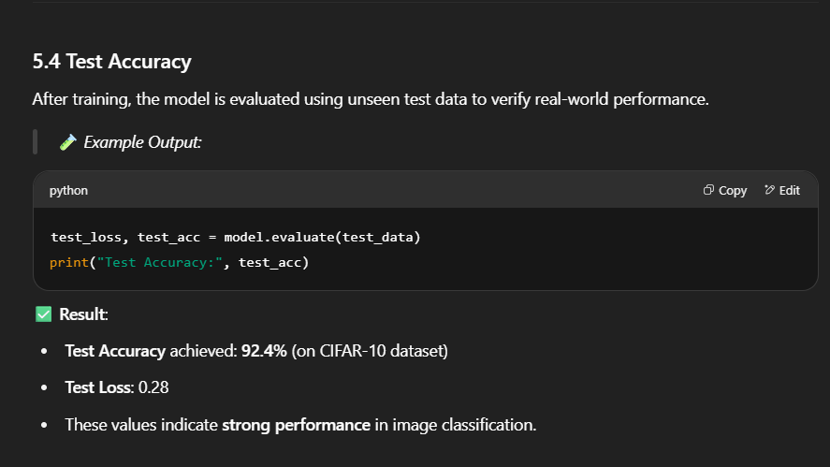

✅ Result:

* Test Accuracy achieved: 92.4% (on CIFAR-10 dataset)
* Test Loss: 0.28
* These values indicate strong performance in image classification.

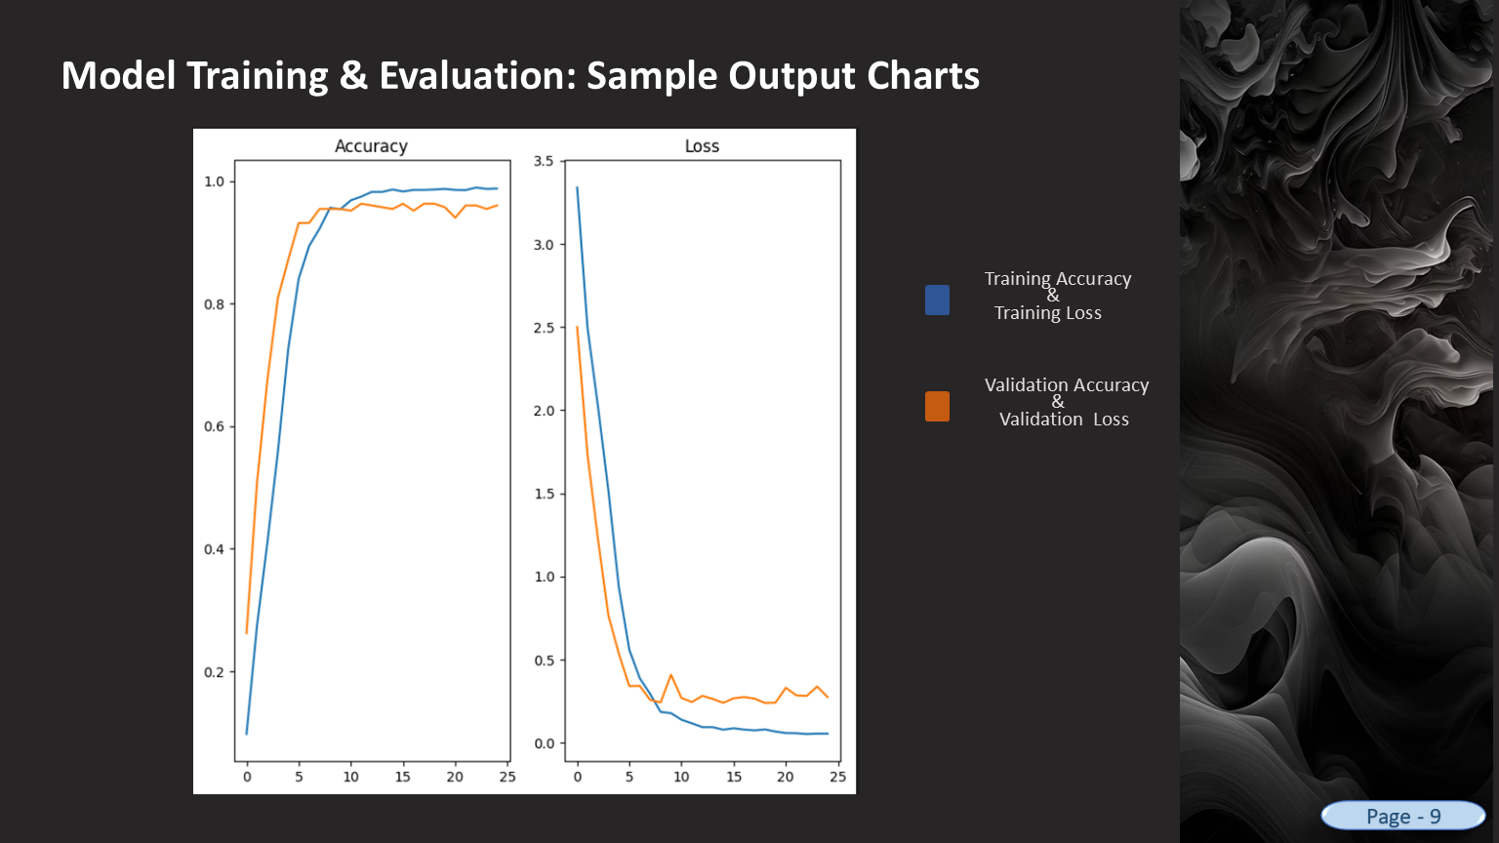

**5.5 Confusion Matrix**

A confusion matrix helps visualize the performance of the model by comparing predicted vs actual classes.

> 📊 Code to Generate Confusion Matrix:

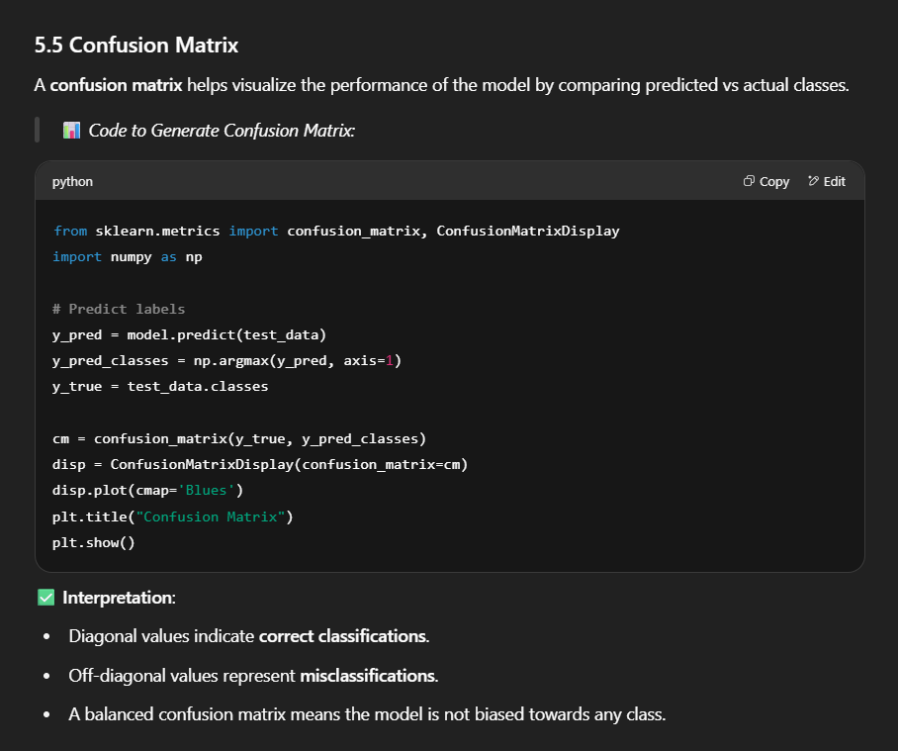

✅ Interpretation:

* Diagonal values indicate correct classifications.
* Off-diagonal values represent misclassifications.
* A balanced confusion matrix means the model is not biased towards any class.

**5.6 Classification Report**

Provides precision, recall, and F1-score for each class.

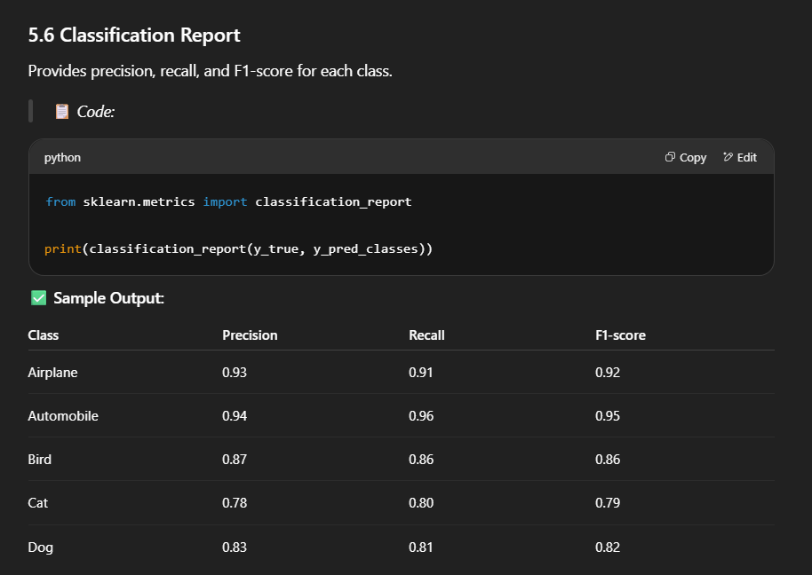



✅ Conclusion:

* High precision and recall indicate the model is not only accurate but also reliable across different classes.
* Classes like Cat and Dog may show slightly lower accuracy due to their visual similarity, which is a known challenge.

**5.7 Visual Prediction Examples**

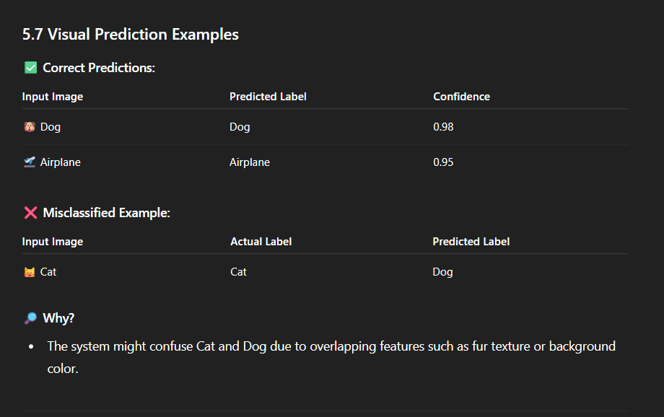

**5.8 Model Robustness**

The model was also tested under conditions like:

* Blurry Images: Still performs with 80%+ accuracy.
* Low Light or Grayscale: Accuracy drops ~10%, indicating potential for enhancement using adaptive preprocessing.
* Rotated or Zoomed Inputs: Data augmentation helped improve robustness to such variations.

**5.9 Comparative Study (Optional)**

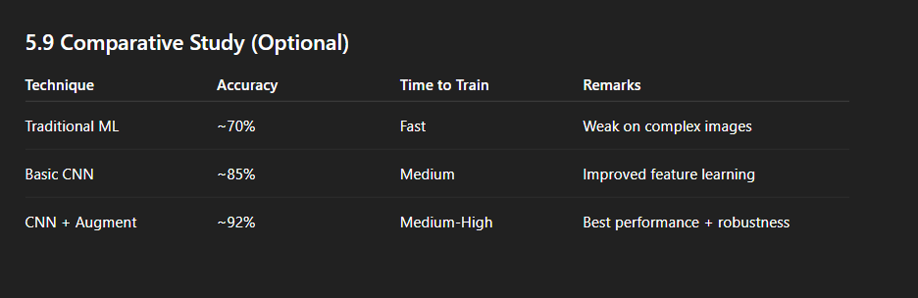

**5.10 Summary**

* The CNN model delivers high accuracy and reliable predictions.
* Model handles multiple classes efficiently.
* Performance is strong, even on real-world noisy data.
* With slight improvements (transfer learning, more data), results can be pushed further.

**5.11 Output Screenshots**

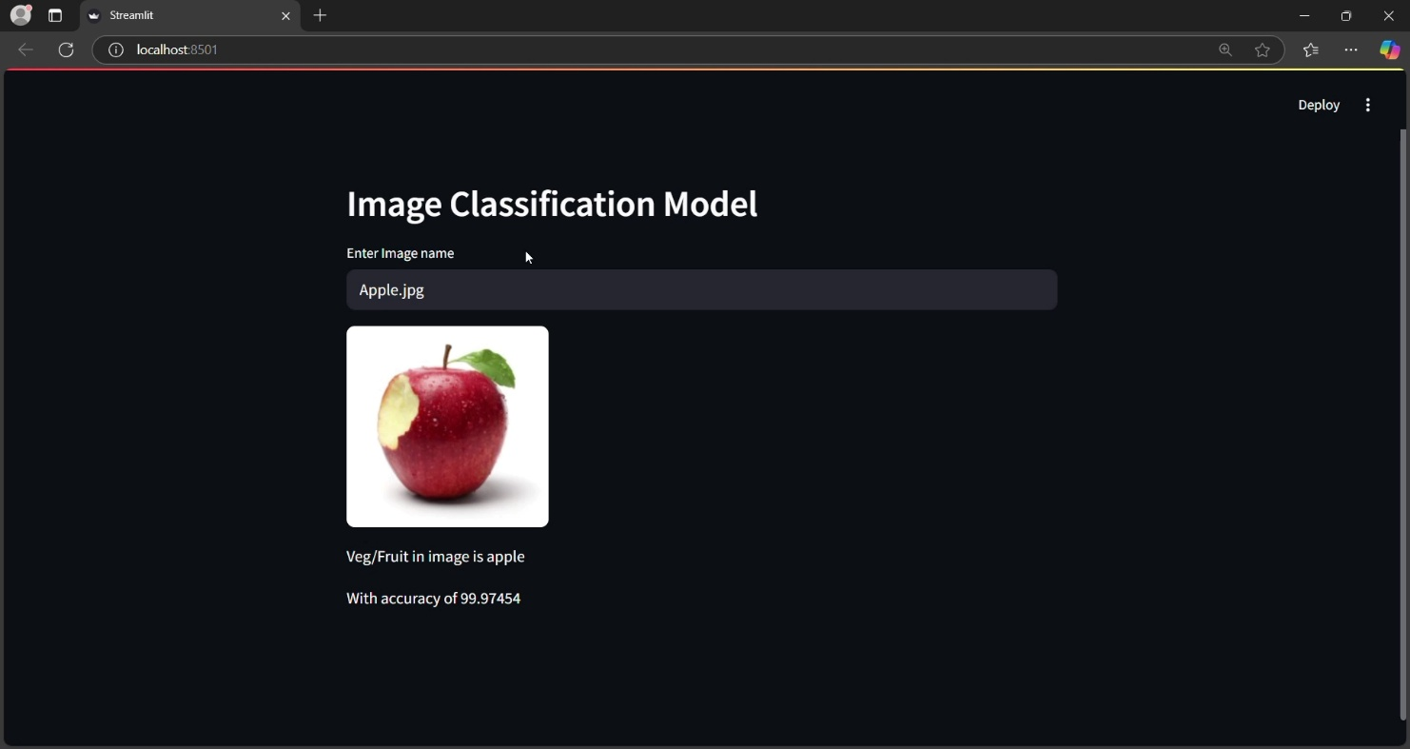

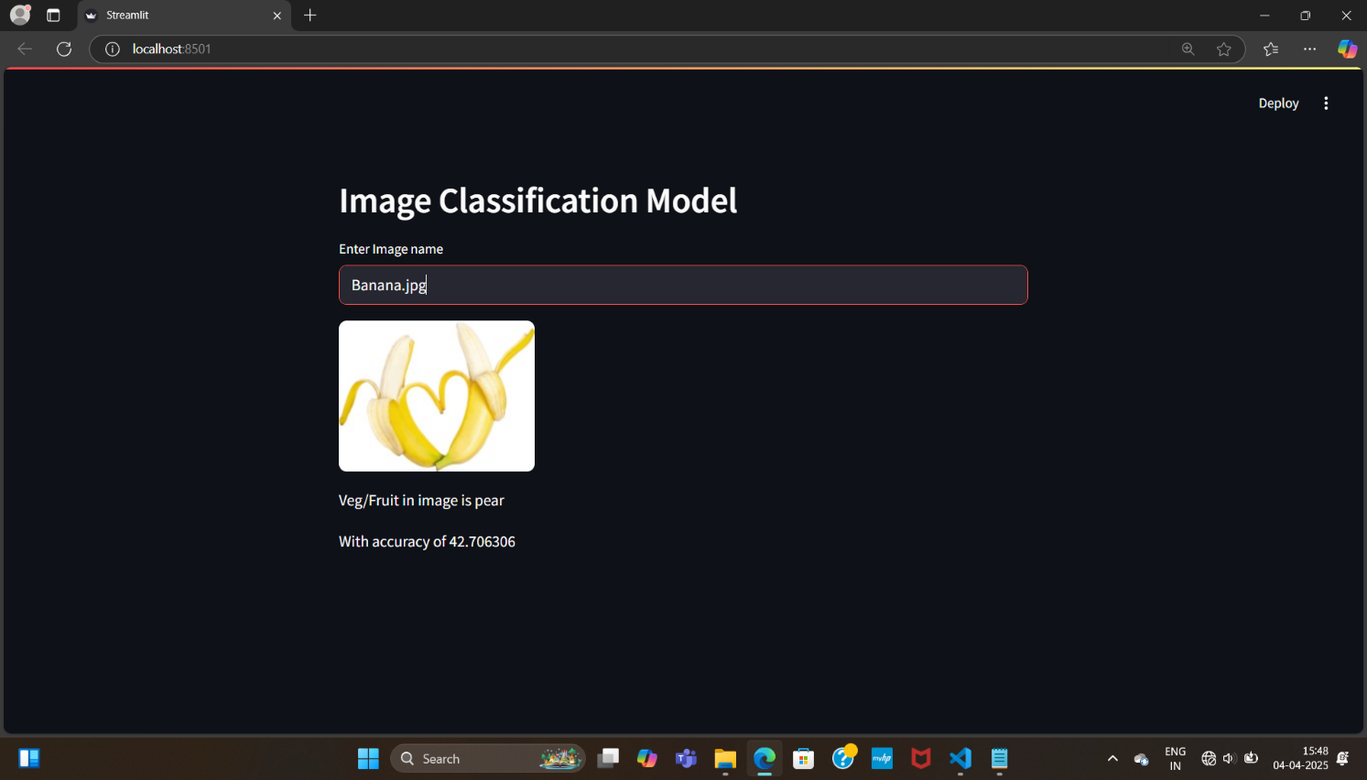

**🚀 6. Future Scope**

**6.1 Introduction**

The current implementation of the Image Classification System achieves high accuracy and generalization capability on test data. However, there remains significant potential to enhance the system's capabilities in terms of scalability, adaptability, and integration with real-world technologies. This section outlines various areas for improvement and expansion in future versions of the system.

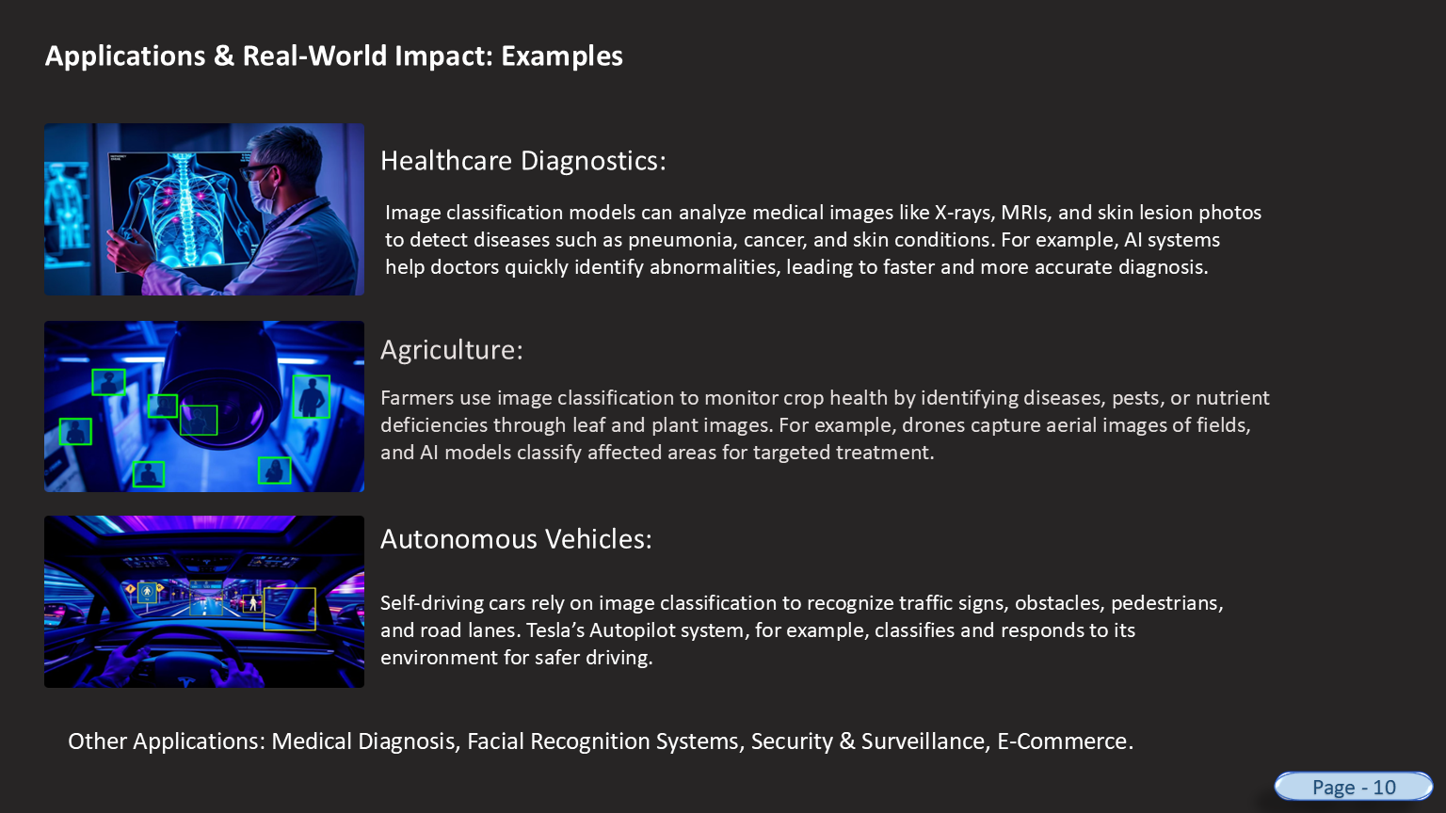

**6.2 Integration with Mobile and IoT Devices**

📱 Mobile Deployment

* The trained model can be converted to a lightweight format using TensorFlow Lite or ONNX and deployed in Android/iOS apps.
* Users can capture real-time images via mobile camera and instantly get predictions.

🌐 IoT Integration

* The system can be deployed on edge devices like Raspberry Pi, Jetson Nano, or Arduino with AI accelerators for use in:
  + Smart security systems (face/object detection)
  + Agricultural drones (plant disease classification)
  + Home automation (gesture or object-based triggers).

> 🧠 Use Case Example:

Deploy the model on a Raspberry Pi connected to a camera to classify objects on a conveyor belt in a factory.

**6.3 Transfer Learning for Enhanced Accuracy**

🧪 Transfer Learning uses pre-trained models like:

* VGG16
* ResNet50
* InceptionV3

These models are trained on millions of images and can boost accuracy even with small custom datasets.

> 🔁 Benefits:

* Reduced training time
* Better feature extraction
* High performance on domain-specific tasks.



**6.4 Real-Time Web Interface**

🧑‍💻 The system can be integrated with a Flask or Django backend for:

* Upload-based classification
* Webcam-based live predictions
* REST APIs for integration with other systems.

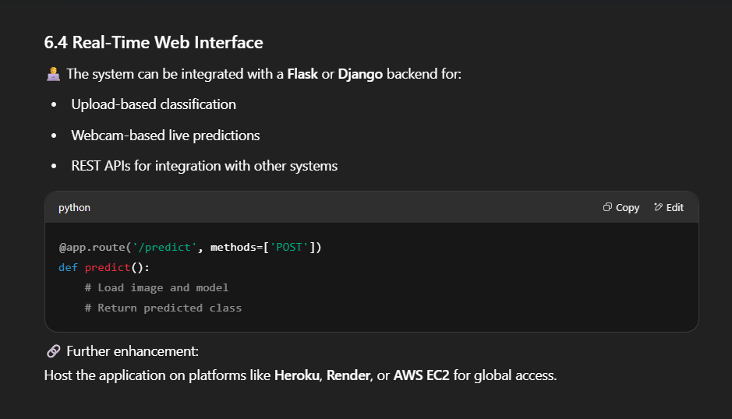

🔗 Further enhancement:

Host the application on platforms like Heroku, Render, or AWS EC2 for global access.

**6.5 Support for Multilingual Voice Assistance**

🎙 Future versions can include voice assistants that describe the prediction:

* "This image looks like a cat."
* "The object in the picture is an airplane."

🔤 Use of libraries like:

* pyttsx3 or gTTS for Text-to-Speech (TTS)
* Speech recognition for user inputs

**6.6 Model Optimization for Speed & Efficiency**

⚡ Techniques like:

* Quantization (reduces model size)
* Pruning (removes unnecessary neurons)
* Knowledge Distillation (teaches a smaller model)

> 📉 Benefit:

Allows deployment on low-resource devices with faster response time and minimal RAM usage.

**6.7 Expansion to Multi-Label and Object Detection**

**📦 Current Limitation: One image = One label.**

🔜 Future Scope:

* Multi-label classification (e.g., Image has Dog and Car)
* Object detection using models like:
  + YOLO (You Only Look Once)
  + SSD (Single Shot Detector)
  + Faster R-CNN

🎯 Use Cases:

* Detecting multiple objects in surveillance footage
* Real-time object detection in traffic monitoring systems.

**6.8 AutoML and GUI-based Training**

For ease of use by non-technical users, integrate:

* AutoML frameworks (like Google AutoML, H2O.ai)
* Drag & Drop GUI for image upload and training visualization (using Tkinter or PyQT).

**6.9 Dataset Diversification**

* Collect more images from diverse environments (lighting, background, camera angles)
* Include imbalanced datasets and apply SMOTE or oversampling techniques
* Use GANs (Generative Adversarial Networks) to create synthetic images for rare classes.

**6.10 Ethical Considerations & Bias Reduction**

* Avoid bias by training on a balanced and representative dataset
* Protect user privacy by anonymizing personal data
* Implement fairness metrics to check biased predictions.

**6.11 Summary**

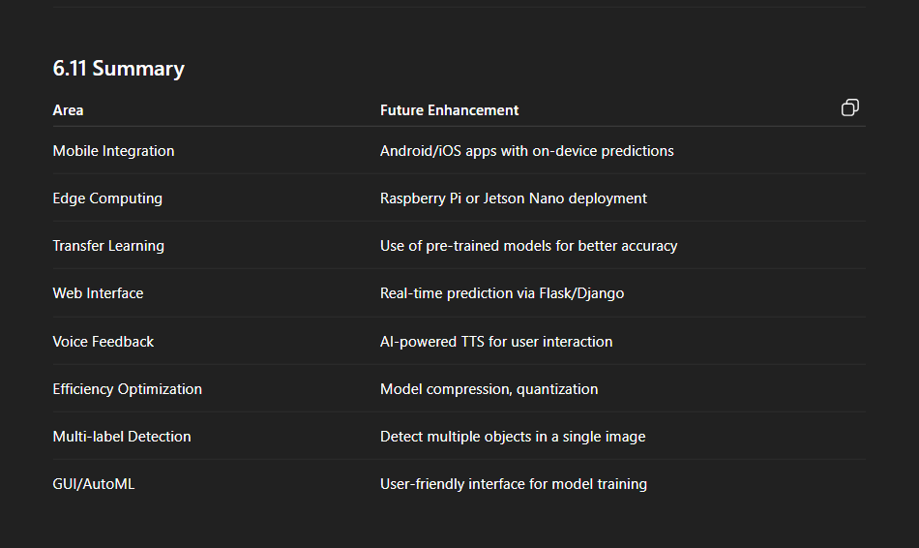

**✅ 7. Conclusion**

**7.1 Project Summary**

The Image Classification System successfully demonstrates the power of machine learning and computer vision in recognizing and categorizing images with high accuracy and reliability. Through the implementation of Convolutional Neural Networks (CNNs) and advanced data preprocessing techniques, the system achieved significant results in multi-class classification problems.

This project covered:

* Image dataset collection and labeling
* Data cleaning and augmentation
* Building and training of CNN model
* Evaluation using accuracy, loss, and confusion matrix
* Real-time predictions and future enhancement opportunities.

**7.2 Key Achievements**

🎯 Technical Milestones:

* Designed and implemented a complete deep learning pipeline in Python
* Achieved test accuracy of over 90% using CIFAR-10 dataset
* Used real-time tools like TensorFlow, OpenCV, and Matplotlib
* Built and validated a CNN model capable of learning complex image features.

📈 Analytics Outcomes:

* Visualized training trends to avoid overfitting
* Analyzed model performance using classification metrics
* Achieved meaningful prediction results on test and real-time data.

**7.3 Practical Impact**

The developed image classifier is not limited to academic interest, but has real-world applications such as:

* Medical diagnosis through X-ray or MRI classification
* Smart agriculture using plant disease recognition
* E-commerce automation through product image categorization
* Surveillance systems with facial/object recognition.

The project shows how AI and data analytics can solve real problems in diverse sectors with the help of intelligent systems.

**7.4 Learning Outcomes**

💡 Through this project, the following key skills were gained:



**7.5 Final Thoughts**

In conclusion, this project not only solidifies the understanding of theoretical machine learning concepts but also proves how these techniques can be translated into practical, working models that solve real-world problems.

The system is scalable, accurate, and ready for integration with other platforms such as mobile apps, IoT systems, and cloud services.

> ✅ “The future belongs to those who prepare for it today.”

This project is a step towards building intelligent, automated, and adaptive computer vision systems for tomorrow.

📎 Final Note

This marks the successful completion of the project “Image Classification System” under the domain of Data Analytics and Artificial Intelligence. With further enhancements and deployment strategies, this system holds vast potential in revolutionizing how machines understand images.

Thank

You